Geometry: Unit 11, Lesson 3

- The measure of an arc is equal to the measure of what?

The central angle that intersects the arc

- Given the equation $(16x-10)+(18x+2)+(34x+18)=180$, what is the value of $x$?

$$x=2.5$$
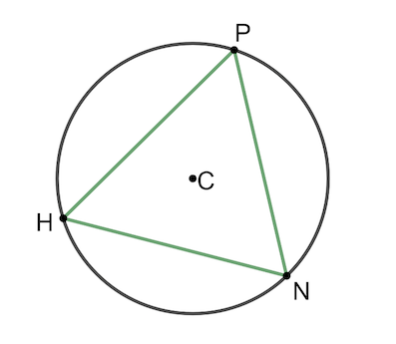
- Circle $C$ is shown, with points $H$, $N$, and $P$ on the circle. $m\hat{HP}=123°$ and $m\hat{PN}=119°$. What is $m\hat{HN}$?

$$118°$$

